Welcome to Oak Class 2022/2023
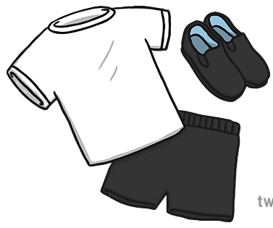
PE Kits
We ask that your child brings in their PE kits on the first day of term. We will leave these on your child`s peg ready for their PE sessions. Your child`s PE kits will be sent home at the end of each half term to be washed/ replenished. Please can we ask that every item within the PE bag is named to avoid loss of items – including socks and shoes!

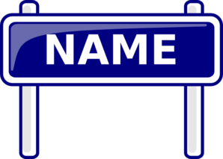
Named everything
As mentioned within the PE kit information please can we ask that every item bought into school is named (including shoes, back packs, coats, jumpers, lunch boxes, water bottles etc.) This is to prevent loss items. It can be very frustrating when items are lost, but if everything is named it is easier to reclaim.

Reading packs
Your child will be sent home with a reading pack. Within this pack they will have a:
- Shared reading book – a book chosen from our book corner for you to enjoy over the week with your children, perhaps at bedtime. The books will be changed weekly
- A reading record – to record the amount of times your children reads or is read to.
- A reading book – this may be a picture book or a book with words that your children can begin to apply their phonics to and practice their reading.
- Phonics Speed sound cards – these are the sounds the children learn within their phonics. These can be practiced at home. Please see the Read Write Inc information for parents leaflet to find out how we teach phonics to your children.
Please make sure your child`s reading pack comes to school daily as we will update these packs with new content as and when your child needs it to support their Early Reading.

Drop off and pick up times/ procedures
Your child`s learning day begins at 8.40am so we ask that children arrive to school promptly at 8.30am to ensure they are settled and ready to commence learning tasks from 8.40am. Your child`s school day finishes at 3pm.
When you bring your child to school we would ask that they line up outside the EYFS gate. A member of staff will come out at 8.30am to walk the children into class. We ask that parents stay outside the EYFS gate.
When you collect your child at 3pm all children will be walked down to the bottom playground. Your child will be sent to you once you arrive into the school playground. Please can we ask that all parents wait on the bottom playground to the left hand side of the building. Please do not wait on the road or outside the school gates as we will not send your child to you if you are waiting there.
Welcome Packs
Please can I ask that all paperwork handed out for new parents within the Summer Term is handed back before the Summer holidays. This will ensure we can set up logins for our online learning journal Tapestry and provide the office with relevant information regarding your child.
Additionally for existing parents/children if any key information such as addresses, telephone numbers, dietary needs have changed please do let us know.
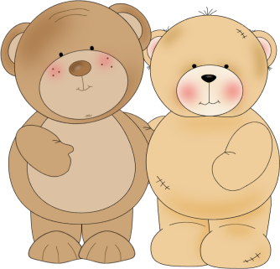
Oak Class Bears
Each week a child will be selected to bring home “Winnie” our class bear. This is an opportunity for your children to show off things they enjoy doing at home. You can take photos to go in the memory book, draw pictures, put brochures/leaflets in of places you have visited. The children can then discuss their adventures with the class bears in class with their friends.
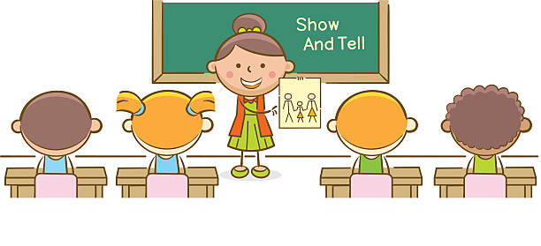
Show and Tell
Each Friday we will have an allocated time for Show and Tell. Each half term your child will be invited to bring in something for show and tell. We will let you know the week before when your child`s allocated date is so they can prepare what they would like to bring. This is a great opportunity to build your child`s confidence in communicating and is a great way of getting to know your children even better.

