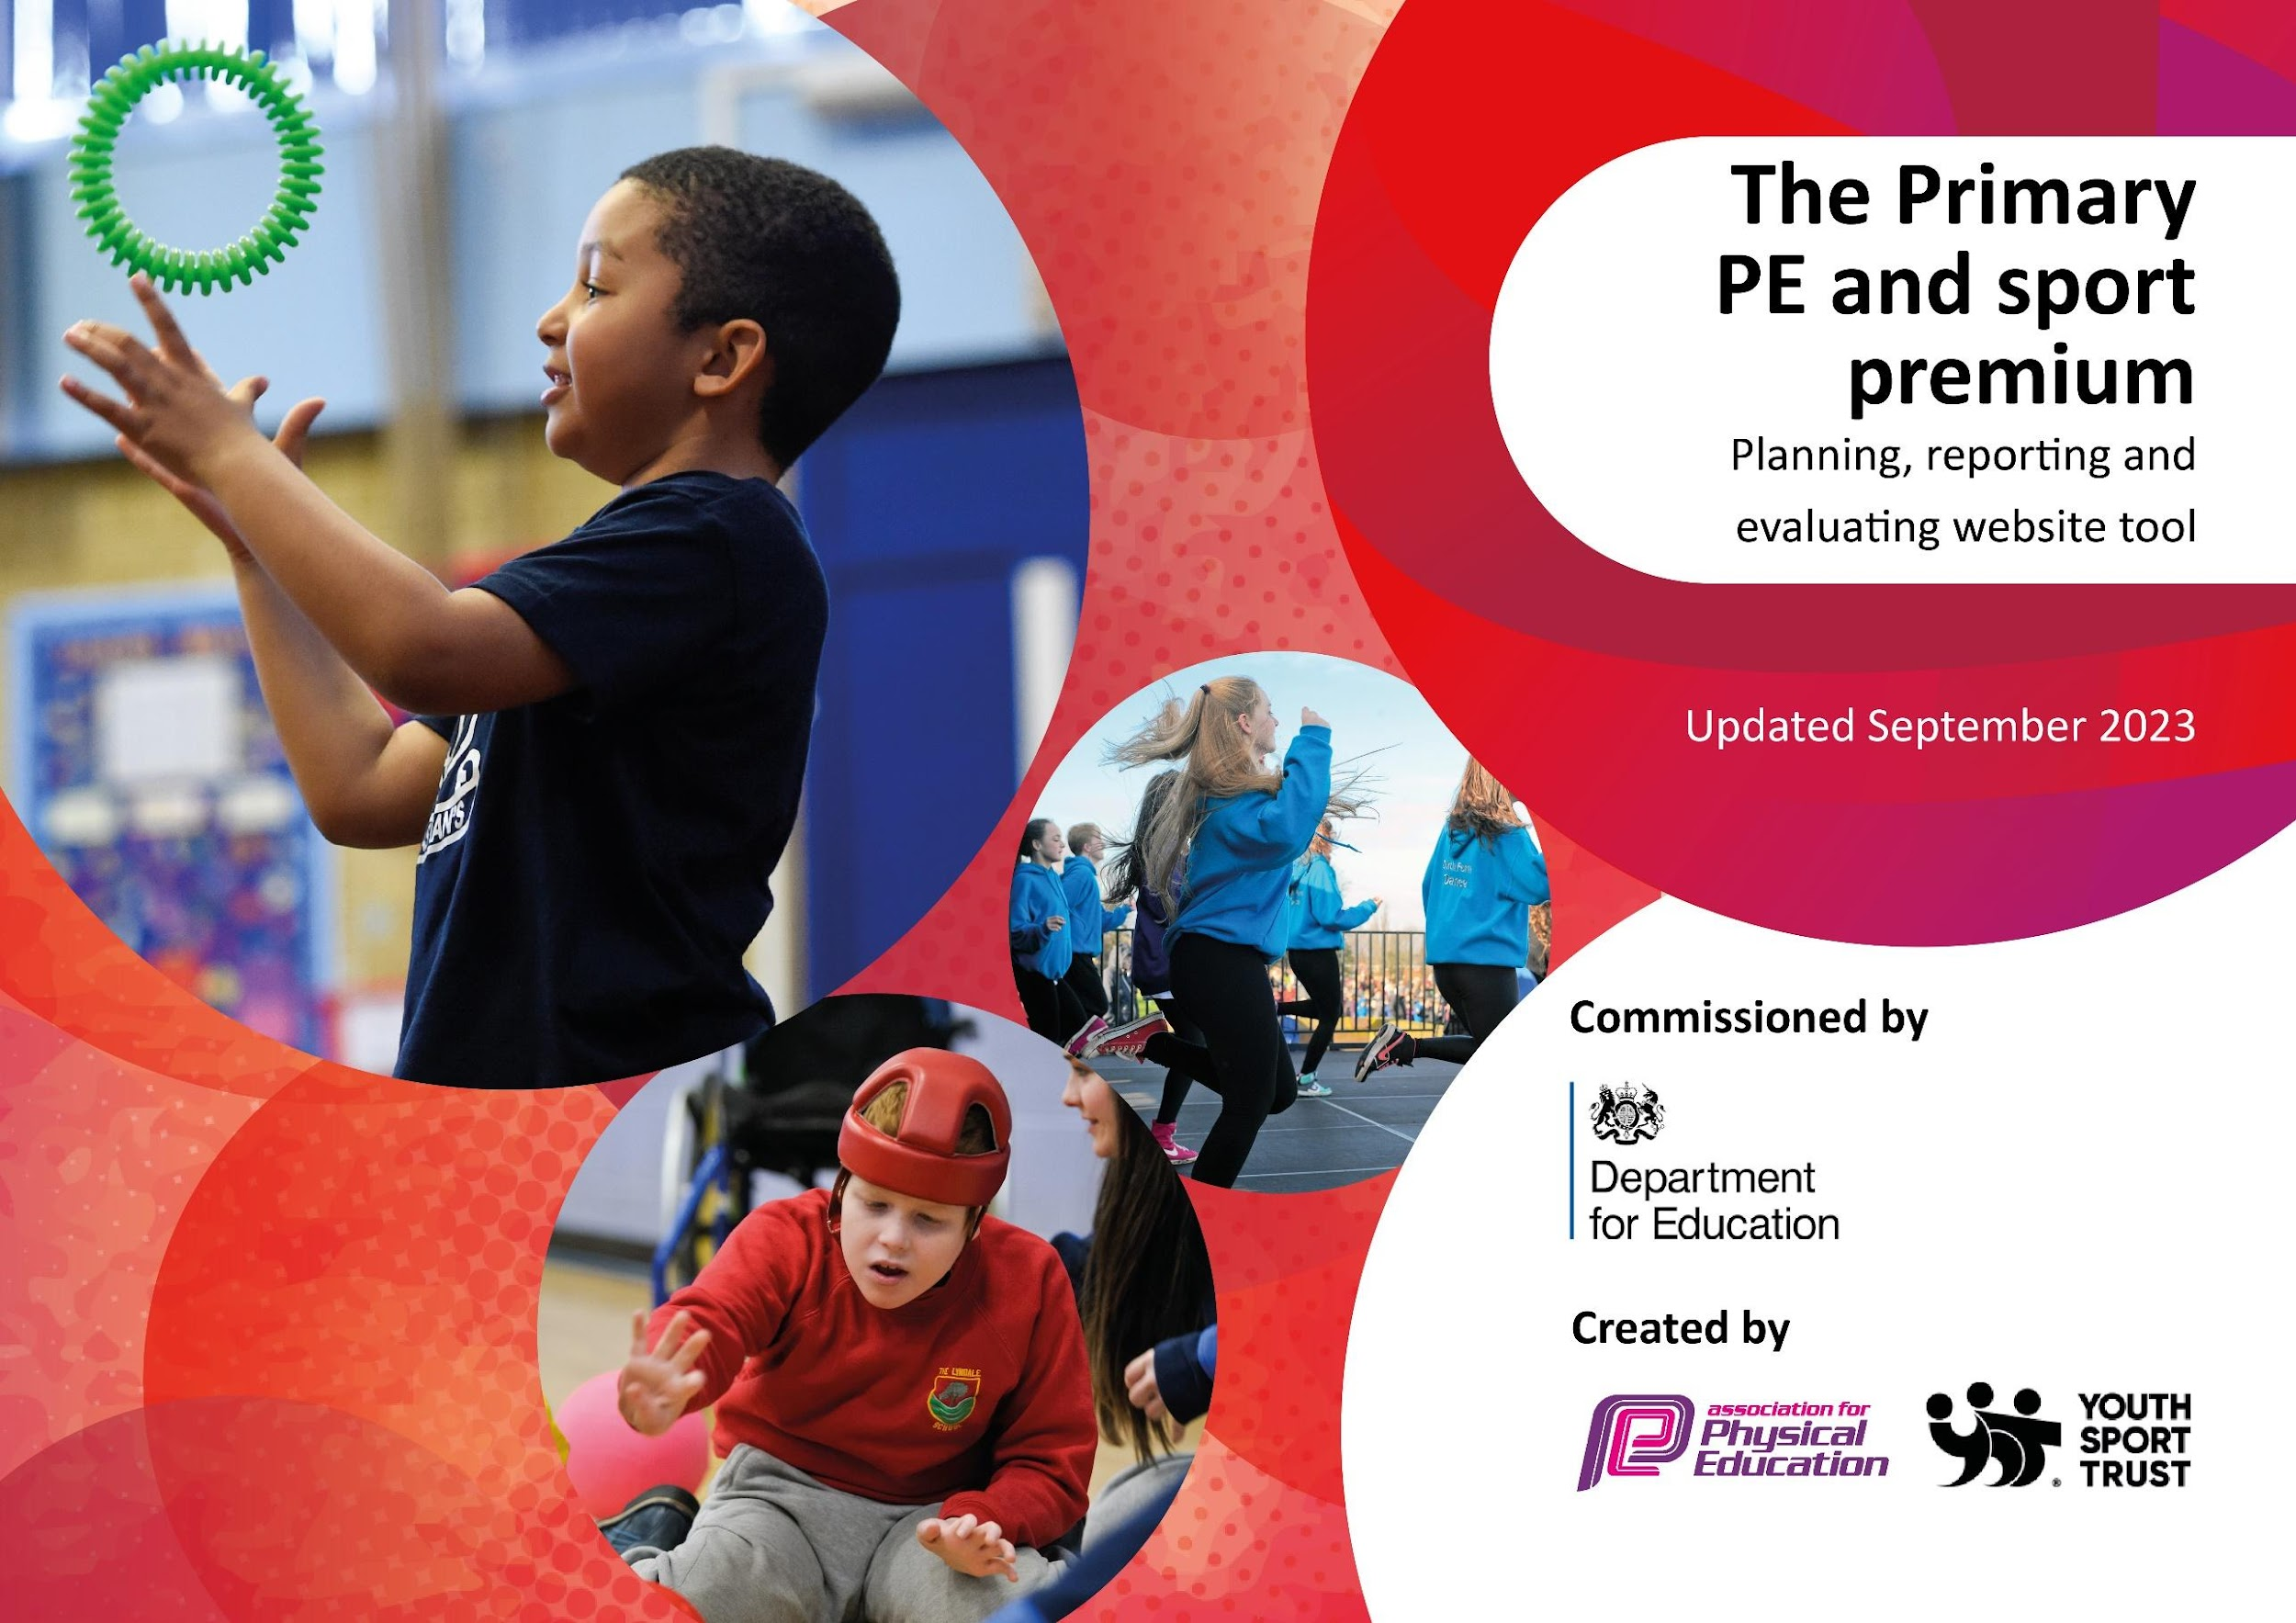

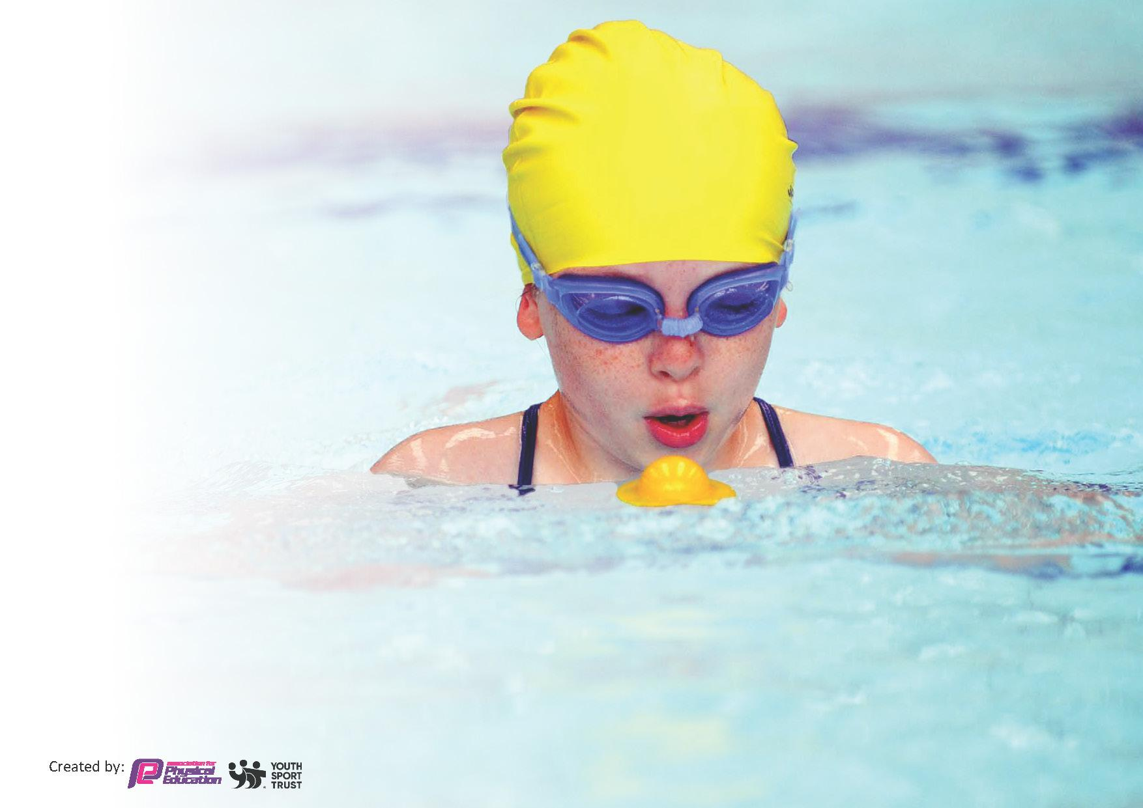
This template can be used for multiple purposes:
by:
- It enables schools to effectively plan their use of the Primary PE and sport premium
- It helps schools to meet the requirements (as set out in guidance) to publish information on their Primary PE and sport premium
- It will be an effective document to support Ofsted inspections enabling schools to evidence progress in Physical Education (PE) and evidence swimming attainment, which forms part of the PE National Curriculum. We would recommend schools consider
the Intent, Implementation and Impact of any spend, as examined within the Education Inspection Framework.

It is important that your grant is used effectively and based on school need.

Schools must use the funding to make additional and sustainable
improvements to the quality of the PE, School Sport and Physical Activity (PESSPA)
they offer. This means that you should use the Primary PE and sport premium to:

- Build capacity and capability within the school to ensure that improvements made now will benefit pupils joining the school in future years
- Develop or add to the PESSPA activities that your school already offers.

The Primary PE and sport premium should not be used to fund capital spend projects; the school’s core budget should fund these. Further detail on capital expenditure can be found in the updated Primary PE and sport premium guidance.

The Primary PE and sport premium guidance, outlines 5 key priorities that funding should be used towards. It is not necessary that spending has to meet all the key priorities, you should select the priorities that you aim to use any funding towards.

Although completing this template is not a requirement for schools, schools are required to publish details of how they spend this funding. Schools must also outline what the impact this funding has had on pupils’ PE and sport participation and attainment and how any spending will be sustainable in the future. All funding must be spent by 31st July 2024.

The Department for Education has worked closely with the Association for Physical Education (afPE) and the Youth Sport Trust (YST) to develop this template and encourages schools to use it. This template is an effective way of meeting the reporting requirements of the Primary PE and sport premium.

Review of last year’s spend and key achievements (2022/2023)

We recommend you start by reflecting on the impact of current provision and reviewing your previous spend.

Activity/Action | Impact | Comments
‘Top-up’ Swimming lessons | 75 % of children left St Catherine’s being a competent swimmer. Giving children a more equal experience of various sports. | KI1- Increasing all staff’s confidence, knowledge and skills in teaching PE and sport.  KI2- Increasing engagement of all pupils in regular physical activity and sport.  KI3- Raising the profile of PE and sport across the school, to support whole school improvement.  KI4- Offer a broader and more equal experience of a range of sports and physical activities to all pupils.  KI5- Increase participation in competitive sport.
Two hours of PE a week for all | Children enjoy two hours of PE a week covering a variety of sporting activities and the skills to p-articipate.  Children know the rules and knowledge needed to be successful in a variety of games.  Children have access to high-quality PE provision.
Half an hour (minimum) of physical activity for each child a day | Helping to tackle childhood obesity in line with the Childhood Obesity Plan.  Children know the importance of keeping physically active
Sports’ Ambassadors providing physical activity through playtime games | Children are proud to be Sports’ Ambassadors.  Children look forward to become SA in Year 5.  Children get to experience and participate in games they may not normally.  Children are able to exercise leadership skills.  Children provide physical activity for others and offer encouragement.
Broad range of activities available for extra-curricular activities | Children have the opportunity to participate in a variety of extra-curricular clubs and activities including: cross country, netball, football, gymnastics, yoga. | Clubs may change each year.
High percentage of children competing in sports’ events

Key priorities and Planning
This planning template will allow schools to accurately plan their spending.

Action – what are you planning to do | Who does this action impact? | Key indicator to meet | Impacts and how sustainability will be achieved? | Cost linked to the action
Staff CPD:  Steven Treble  Real PE (Training)  PE Hub | All children  All staff  Specialised Teacher – Steven Treble | KI1- Increasing all staff’s confidence, knowledge and skills in teaching PE and sport.  KI2- Increasing engagement of all pupils in regular physical activity and sport.  KI3- Raising the profile of PE and sport across the school, to support whole school improvement.  KI5- Increase participation in competitive sport. | Staff confidence, knowledge and skills are increased  Children access a high-level of teaching for 1 PE lesson a week  Children access a high-level of teaching which covers a range of different sports and skills  Preparation for participation in competitive sport.  Monitoring the equipment and perform checks to ensure the sustainability of the equipment. | £3780  £695  £446
Equipment | All staff including Midday Assistant  All children | KI1- Increasing all staff’s confidence, knowledge and skills in teaching PE and sport.  KI2- Increasing engagement of all pupils in regular physical activity and sport.  KI3- Raising the profile of PE and sport across the school, to support whole school improvement.  KI4- Offer a broader and more equal experience of a range of sports and physical activities to all pupils. | Equipment used at playtimes to promote active play  Staff will have confidence in using equipment; equipment will be used to ensure high-quality teaching  Everyone has access to equipment available.  Midday assistant will be able to provide physical activity on the playground  Sports’ Ambassadors will be able to provide physical activity at lunchtimes. | £1000
Midday assistant | All children can access Midday assistant’s provision | KI2- Increasing engagement of all pupils in regular physical activity and sport.  KI3- Raising the profile of PE and sport across the school, to support whole school improvement.  KI4- Offer a broader and more equal experience of a range of sports and physical activities to all pupils. | Increasing engagement of children playing a variety of sports and engaging in different activities on the playground that are accessible for all.  Will support and encourage children to engage in physical activitity.  Will allow all children to equal access/opportunity to activities they may not usually experience. s | £2863
Forest School | All children (throughout the year)  All staff (throughout the year) | KI2- Increasing engagement of all pupils in regular physical activity and sport.  KI4- Offer a broader and more equal experience of a range of sports and physical activities to all pupils. | Physical gains from outside learning.  Giving a broader range of physical activity | £2432
Participating in extra sports’ events  SLA – Sports in the local authority  (Extra-curricular) Clubs | All children  All staff  Parents (volunteers) | KI1- Increasing all staff’s confidence, knowledge and skills in teaching PE and sport.  KI2- Increasing engagement of all pupils in regular physical activity and sport.  KI3- Raising the profile of PE and sport across the school, to support whole school improvement.  KI4- Offer a broader and more equal experience of a range of sports and physical activities to all pupils.  KI5- Increase participation in competitive sport. | All pupils will participate in school based competitive events such as Sports’ Day  Staff will experience how the knowledge and skills they have, affect a game  Staff will be confident in helping arrange sporting events/ running of sporting events.  Pupils from classes invited to attend sporting events held by schools or sports facilities.  Pupils from classes invited to attend clubs  Wider range of sports offered and wider range of sporting opportunity/activities.  CPD for staff  Opportunities to involve parents and volunteers.  Opportunities to celebrate outcomes and participation levels of sporting events | £2432  £700
Additional physical activity  Coaches (to and from events)  Additional “top-up” swimming lessons | Some children  Some staff  Parents (volunteers) | KI2- Increasing engagement of all pupils in regular physical activity and sport.  KI3- Raising the profile of PE and sport across the school, to support whole school improvement.  KI4- Offer a broader and more equal experience of a range of sports and physical activities to all pupils.  KI5- Increase participation in competitive sport. | Equal opportunities to participate in competitive sports  Opportunities to celebrate outcomes and participation levels of sporting events  Children have opportunities to attend sporting events  All children to have the opportunity to reach objectives for swimming. | £1000  £1806

Key achievements 2023-2024
This template will be completed at the end of the academic year and will showcase the key achievements schools have made with their Primary PE and sport premium spending.

Activity/Action -Key indicators | Impact | Comments
Top-up swimming lessons | 82% of children left St Catherine’s being able to swim 25m proficiently. | Children to have swimming lessons before entering UKS2.  Questionnaire at beginning of each year to parents about swimming capabilities to identify those who need top-up.
Staff CPD  Steve Treble/PE hub/Real PE | Staff confidence and skills in teaching PE has improved.  Learning has covered a variety of different sports and skills, including: handball, tag-rugby, gymnastics, dance, football, athletics, cricket, rounders | Children accessed a high-level of teaching with a specialist coach.  Next year, PC to carry out more DDIs to see implementation of learnt skills.  Staff questionnaire on confidence in teaching PE and areas to improve. CPD appropriately
Equipment | Children are more physical at playtimes.  Children are able to independently use skills at playtime.  March 2024 - balls, hoops, skipping ropes, scoop ball and cup. | A range of physical activities happen at playtime that wouldn’t have happened without this new equipment e.g. skipping ropes.  Everyone has had the opportunity to access a variety of equipment.
Midday assistant | Physical activity and supervision for activities has happened at lunchtime. | This to continue next year to enable football pitches to be supervised and supervision of sports ambassadors providing games.  PC to create bank ideas for support staff.  Pupil survey for playtime activities to ensure a variety of activities which encourage participation.
Forest School | Children have experienced a broader range of physical activities including those that would benefit team games.  Children have had the opportunity to work as part of a team and participate in team building opportunities. | Children to complete pupil voice on FS each term.
Sports in the Local Authority | Opportunities for each Key Stage in competitive sports.  Children participated in cross-country, multi-skills, netball, football and tag-rugby sports.  Children coached in tag-rugby, football, netball, cross-country and multi-skills. | Tag Rugby won for 10th year which children were proud of.  All children in Year 1 and 2 had the opportunity to attend multi-skills event.  Children look forward to events ; Colmer’s Hill cancelled this year due to the bad weather.
Extra-curricular | Children given extra-opportunities to do other sports outside of their PE lessons – gymnastics, football, tag-rugby, running, dodgeball, forest school. | Identify children who have missed movement skills to be offered invite-only afterschool club focussing on skills. (Steve Treble).

Swimming Data
Meeting National Curriculum requirements for swimming and water safety.
Priority should always be given to ensuring that pupils can perform safe self-rescue even if they do not fully meet the first two requirements of the National Curriculum programme of study

Question | Stats: | Further context  Relative to local challenges
What percentage of your current Year 6 cohort can swim competently, confidently and proficiently over a distance of at least 25 metres? | 82% | Children have top-up lessons in the summer term which are taught be qualified swim teachers.
What percentage of your current Year 6 cohort can use a range of strokes effectively [for example, front crawl, backstroke, and breaststroke]? | 82%

What percentage of your current Year 6 cohort are able to perform safe self-rescue in different water-based situations? | 82% | All children participated in the safe self-rescue lesson. Those who could not swim proficiently participated using floats. Children showed a knowledge of Coastguard flags and their meanings – The Coastguard came to talk to all pupils about water safety in the Summer Term.
If your schools swimming data is below national expectation, you can choose to use the Primary PE and sport premium to provide additional top-up sessions for those pupils that did not meet National Curriculum  requirements after the completion of core lessons. Have you done this? | Yes/No
Have you provided CPD to improve the knowledge and confidence of staff to be able to teach swimming and water safety? | Yes | Staff learn from the swimming instructors at the centre when watching them teach.

Signed off by:

Head Teacher: | Paula Fearn
Subject Leader or the individual responsible for the Primary PE and sport premium: | Penny Cross  PE Lead/Class Teacher
Governor: | Claire Hewitt  Curriculum Governor
Date:

