The Fairtrade Mark symbol is made up of a blue sky that symbolises optimism, and an arm, raised in the air – this symbolises empowerment.

As a Geographer I can:

Use world maps, atlases and globes.

Find the location of hot and cold areas of the world in relation to the Equator and the North and South Pole.

Describe farms in Kenya and Dorset.

Describe seasons and daily weather patterns.

Compare similarities and differences between Kenya and Dorset.

Understand why Fairtrade is important.

Say which products are made where in the world and why.

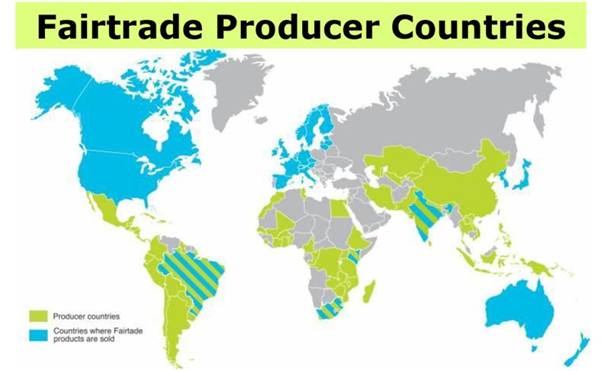

**Key Vocabulary** Northern/Southern hemisphere, maps, atlases, globes, beach, cliff, coast, forest, hill, mountain, sea, ocean, river, soil, valley, vegetation, equator, weather, climate, seasons, country, continent, Fairtrade, Africa, Kenya, England, Dorset, produce, products, crops, arable, pastoral, mixed sloping, flat, dairy

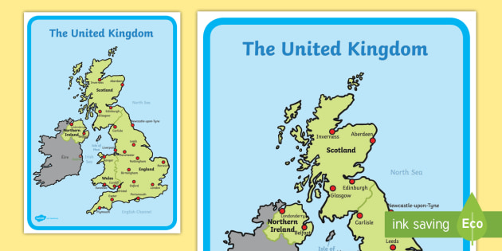

What are the 7 continents and 5 oceans of the world?

There are 7 continents which include: North America, South America, Europe, Africa, Antarctica, Asia and Australia. There are 5 oceans which include: Pacific Ocean, Atlantic Ocean, Arctic Ocean, Indian Ocean and the Southern Ocean.

Google maps

Atlases

brochures

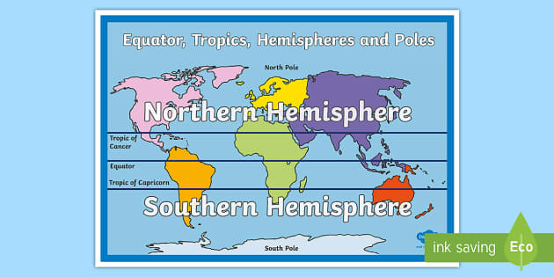

**Enquiry Questions …**

*Can I find Dorset and Kenya on a map?*

*Can I find the equator and locate hot and cold countries?*

*Can I describe the physical features of a farm in Kenya and Dorset?*

*Can I use graphs to show seasonal weather patterns?*

*Can I compare by noticing similarities and differences?*

*What is fair trade?*

*Why is fair trade important?*

*How do I know a product is fair trade?*

*What products are grown around the world and why?*

Things learnt along the way …

What would I like to find out more about in the future?

What would I like to find out more about?