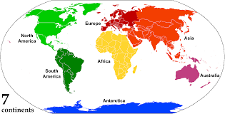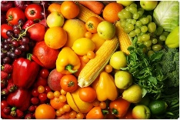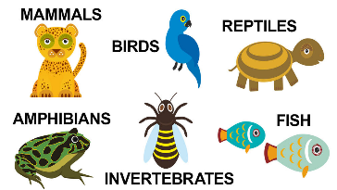

Spring Term 2023

**Art and Design**

**What is a Kenyan pattern?**

Using foam tiles we will be creating our own patterns based on Kenyan patterns to create a large canvas piece of art.

**How can I use collage effectively?**

We will be exploring the Kenya wildlife and using collage to create a silhouette picture.

**Geography**

**How is Bridport different and similar to Kenya?**

Exploring the world, thinking about the seven continents and the worlds oceans. Focus on Kenya thinking about the lifestyle and culture compared to Bridport. Looking at farming here in Bridport compared to farming in Kenya and exploring the similarities and differences.

**Experiences / Events**

* Forest school every Friday.
* TBC trip to support learning about animals and Kenya.
* Wednesday 8th February @ 2.40pm Learning exposure
* TBC open classroom phonics workshop 2

**Oak Class**

**Science**

**How are animals and plants different?**

Thinking about how plants and animals are both living things. How animals can be grouped based on their features. Exploring animals around the world.

**Why is the human body so important?**

Thinking about body parts and labelling those parts. Exploring the 5 senses and how each sense supports different day to day functions.

**Computing**

**What is an algorithm?** We will be exploring algorithms and how we can use these to create our own simple sets of instructions on the computers.

**What is digital imagery?** Using technology we will be capturing images and uploading these safely online to use within our work.

**Maths (Power Maths)**

**Reception**

Unit 8 – comparing numbers within 10

Unit 9 – addition to 10

Unit 10 – measure (length, weight and height)

Unit 11 – number bonds to 10

Unit 13 – exploring patterns

**Year 1**

Unit 6 – Unit 6 numbers to 20

Unit 7 – addition to 20

Unit 8 – subtraction within 20

Unit 9 – numbers to 50

Unit 10 – introducing length and height

Unit 11 – Introducing weight and volume

**English, Communication and Language**

**Reception**

Read Write Inc Phonics – we will be learning new sounds throughout this term. We will be sounding out and blending 5 sound words and beginning to read ditty sentences and books.

**Year 1**

Read Write Inc Phonics – we will be continuing to work through Set 3 sounds with a specific focus on identify special friend sounds in all word to enable us to read them.

**Talk Through Stories –** We will be reading a range of stories, discussing the plot, the characters and the vocabulary choices.

**Design Technology**

**How are fruits and vegetables different?** Exploring different fruits and vegetables, thinking about where and how they grow and what they can be used for. We will be tasting fruit and making smoothies as well as designing and making our own smoothie.