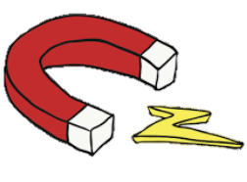
KNOWLEDGE ORGANISER
FORCES AND MAGNETS
Y3

-A magnetic field is the area in which a magnetic force can be felt. A magnet will only attract or repel a magnetic object when it enters its magnetic field.
Overview |  |  | Magnets
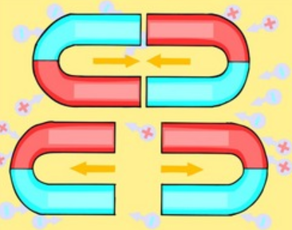  - Forces are pushes and pulls which make things move and stop moving.  -Most forces need contact between objects, but magnets can act at a distance.  -Magnets are made of materials that create a magnetic field (the area in space where the force of magnets can be detected).  -Magnets have at least one north pole and one south pole.  -Magnets can attract or repel one another. They attract some materials & not others. |  |  | 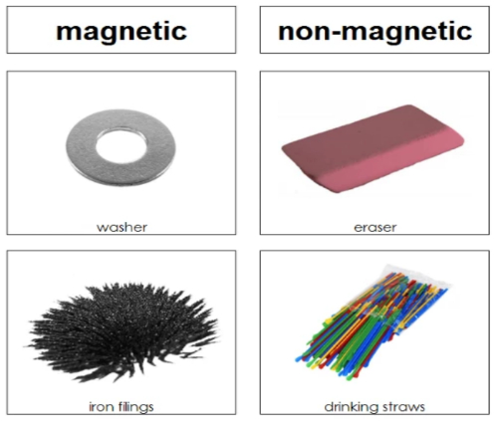 | 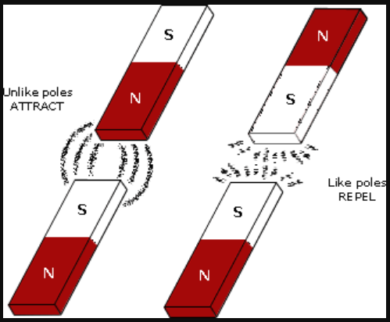 | -A magnet is an object that is made of materials that create a magnetic field.  -Magnets create a ‘magnetic force’ – this is a force that causes objects to attract (pull closer together) or repel (push further apart).  -Unlike most other forces, ‘magnetic force’ does not require objects to touch one another – magnets can act at a distance. | -Magnets have two poles – a north pole and a south pole.  -The north pole of one magnet will repel the north pole of another magnet. However, it will attract the south pole of another magnet.  -
Forces
What are forces?
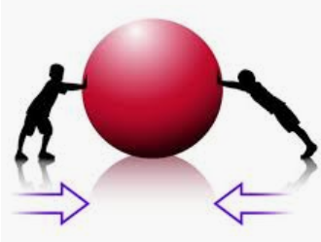
-A force is the push or pull of an object in a particular direction.

-Forces are shown by arrows in diagrams. The bigger the arrow, the bigger the force. The direction of the arrow shows the direction of the force.
 |  |  | Magnetic Fields
-Magnetic fields cannot be seen with the human eye. However, spreading iron filings over the magnetic field allows us to see the magnetic field, as the filings cling to it.
-Magnetic fields can pass through air. Some can even have an effect through solids and liquids (depending on the strength of the magnet).
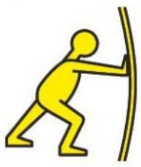  Pushes and Pulls  -A push is the force that moves an object away from something.  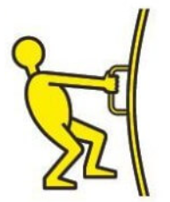  -A pull is the force that brings an object towards something.  -A push and a pull are opposite forces, moving objects in different directions. | Balanced and Unbalanced Forces  -If two forces are balanced, they are the same size but are acting in opposite directions. If the two forces are acting on an object, then its motion will not change.  -When two forces acting on objects are not equal in size, they are called unbalanced. Unbalanced forces change the way and/or speed that something is moving, e.g. they can make objects speed up/slow down.
 |  |  |  | 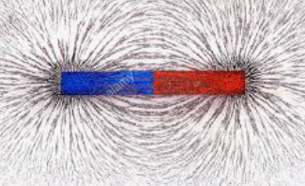

Non-Magnetic Materials
Magnetic Materials
Cobalt
Gadolinium
Gold
Leather
Wood
Rubber
Copper
Nickel
Steel
Iron

