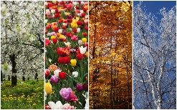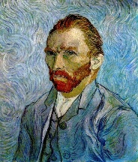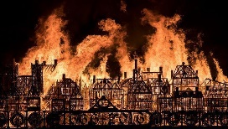

**Experiences / Events**

* Wellie walk around our local area.
* Fireman Visit
* Learning exposure for all parents Wednesday 19th October @ 2.40pm
* Phonics Parent workshop date to tbc 2.30pm – 3pm.

**Oak Class**

**Science**

**What is a season? Why do they change?** What noticeable changes can we observe when the seasons change? Why do we have shorter and longer days throughout the year? Why do we only see the moon at night? What is a life cycle?

**Autumn Term 2022**

**Art and Design**

**How can I paint a portrait of myself?**

What are primary colours? What happens when we mix colours? Who was Vincent Van Gogh? What shapes are on our faces?

**Computing**

How can I keep safe online?

How can I log on to a computer? Why do computers have passwords?

How can I navigate around computer software using a mouse?

What are the different parts of a computer?

What is a bee bot? what can I do with it?

**Maths (Power Maths)**

**Reception**

Unit 1 – numbers to 5

Unit 2 – comparing groups within 5

Unit 4 – change within 5

Unit 5 – number bonds to 10

Unit 6 – space

Unit 3 – shape (3D and 2D shapes)

**Year 1**

Unit 1 – Numbers to 10

Unit 2 – part whole to 10

Unit 3 – addition and subtraction within 10 (1)

Unit 4 – addition and subtraction within 10 (2)

Unit 6 – Unit 6 numbers to 20

Unit 5 – 2D and 3D shapes

**English, Communication and Language**

**Reception**

Read Write Inc Phonics – we will be learning new sounds throughout this term. We will begin to sound out and blend 2 or 3 sounds together to read words.

**Year 1**

Read Write Inc Phonics – we will be continuing to work through our Set 2 and Set 3 sounds which we will be able to practice when reading our books.

**Talk Through Stories –** We will be reading a range of stories, discussing the plot, the characters and the vocabulary choices.

**History**

**How have homes changed?** How have the homes in our local area changed over the years? What are our buildings and homes made of? Why are they made of these? What was The Great Fire of London? Why did London burn?

**Design Technology**

**How can I join fabric together?** Focussing on the story of Little Red Riding, we will be making a character puppet. Thinking about the materials we could use to make the puppet, what techniques can we use to join the pieces together?

**Geography**

**Where do we live?** What homes can we see in our local town of Bridport? Where is London?

As a geographer I will be able to draw a simple map of my local area.