St Catherine’s RC Primary School
Sycamore Class (Year 2) Autumn Curriculum Map
Subject | Autumn
English | 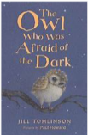  Narrative - The Owl Who Was Afraid of the Dark  Non-fiction - Hibernation  Narrative - Christmas story animation
Maths | Numbers to 100  Addition and subtraction  Money  Multiplication and division
History / Geography | Heroes and Heroines – Benjamin Jesty and Edward Jenner
Science | Animals including Humans
P.E. | 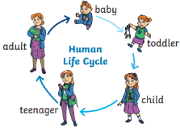  Attack, Defend Shoot  Co-ordination and balance  Gymnastics  Balance/Agility
Computing | Online Safety
Music | Hands, Feet, Heart  Nativity
Art/DT | Food – A balanced diet
R.E | Beginnings  Signs and symbols  Preparations
PSHE/RSE | 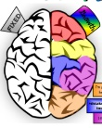  Say no to bullying  Growth Mindset

