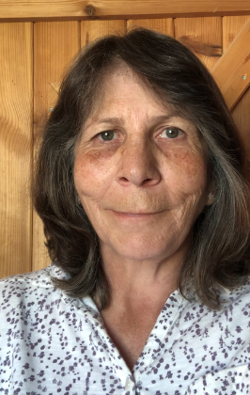

Hello Year 3. I hope you are all keeping well and taking care and making the most of your time at home. Perhaps you are able to pursue your favourite hobby or are exploring new ones.

Miss Thomas and myself are putting up activities and tasks for you to follow to develop your learning. Keep thinking about the fraction work you were covering last term and start to do lots of measuring. All kinds of measuring, length, height, weight, time... How many times can you say supercalifragilistic in 60 seconds. Make guesses before you actually do the measuring. Were you close?

As we have been developing our understanding of the building blocks of music we have thought a lot about the beat, or pulse, in music.

Purplemash (your parents will be receiving your logins soon) has a section called 2beat which gives you the opportunity to build your own rhythm section.

Start with just a few sounds and then gradually add more.

You can group your beats in groups of three or four. Listen to your favourite music and decide if the beats are in groups of three or four. Count out loud 1,2,3 1,2,3 and you will feel if your counting fits. If it doesn't seem to fit, try counting 1,2,3,4 1,2,3,4. You will soon be able to hear if 3 beats or 4 beats fit into the music you're listening to. Then play your pattern again on 2beat and see if your pattern can play along with your favourite music?

Out of the Ark Music https://www.outoftheark.co.uk/ has a free music at home learning page which you might like to explore with a different song for each day.

Bye for now,

Mrs Lewendon

If you have any questions or just want to say hello it would be great to hear from you! klewendon@stcatherinesbridport.dorset.sch.uk

