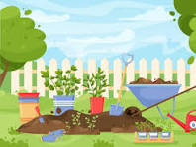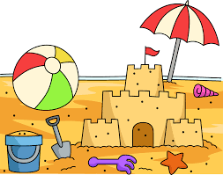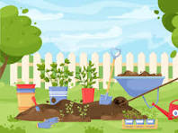

**Literacy** In Drawing Club we will be exploring the following stories as stimuli and vocabulary:

The Very Hungry Caterpillar, Superworm, Jack and the Beanstalk, Farmer Duck, Rosie’s Walk, The story of little mole, Lost and found, Tiddler, Penguin, The night pirates, Dear Zoo, Pirate Pete

The children are actively taking part in more writing based activities through their continuous provision and their focused phonic time. The children are becoming familiar with using a sound mat to support their writing and will continue to apply the use of their Fred Fingers for spelling.

**Phonics**

In phonics we will be learning the special friend sounds (2 letters making one sound) and continuing to build upon blending and reading fluency.

**Communication and Language**

Through discussions during inputs, questions and critical thinking the children are encouraged to discuss their ideas and feelings within small and large group contexts. Through regular circle times children are encouraged to suggest ideas and share something they would like their peers or teachers to know. Through imaginary play the children will be encouraged to explore their imaginations and share their ideas through active discussions.

**Personal, Social and Emotional**

**Through our play based exploratory learning we will continue to encourage the children to play collaboratively together, by sharing and turn taking, as well as encouraging shared conversations to express their own ideas.Through our continuous provision we will continue to working on positive interactions with our friends.**

**We are exploring our own and others feelings and explore how we can support our friends when they might be feeling a little sad or overwhelmed, alternatively how to control our excited when we are enthused.**

**Physical Development**

**Gross Motor**

The children will be exploring movements in PE thinking about how they can manage their body, negotiating spaces, and using their bodies to balance objects and move objects around.

**Fine Motor**

We will be using our strengthened hand muscles to create precise outcomes including drawings, letter writing, number writing and building up to work writing.

**Mathematics**

Through Power Maths -the mastery maths approach we will be exploring the following units.

Unit 12: subtraction within 10

Unit 13: exploring patterns

Unit 14: counting on and counting back

Unit 15: numbers to 20

Unit 16: numerical patterns

Unit 17: shape (composing and decomposing)

Unit 18: measure (volume and capacity)

Unit 19: sorting

We will be Subitising amounts up to 5. Singing songs and learning rhymes to support our understanding of number fluency and ordering of such numbers.

**Enrichment**

* **Forest school**
* **Vurlands trip**
* **Washingpool farm**

**Summer Term 2024**

**In the Garden by the Sea**

**Expressive Arts and Design**

Art – we will be building our skills to create our own portraits with inspiration taken from Pablo Picasso.

DT – making a boat. We will be exploring how boats are made and will use this knowledge to design and make our very own using the best waterproof materials.

**Knowledge and Understanding of the World**

Geography - We will be exploring our homes compared to homes around the world with a focus on Kenya.

History -We will be exploring the past with a focus on seasides. We will be looking at how visits the the seaside have changed over time.

Science – we will be exploring bugs and their habitats, liquids, plants and trees.