The vicious world of Viking sagas…
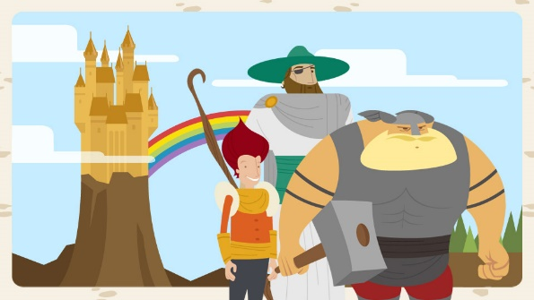
Who were the Viking gods and goddesses?
What makes a Viking saga?
What is so special about Thor’s hammer Mjolnir?

Creative Topic Learning – Weeks 3-5
Week 3 – Who were the Viking gods and goddesses?

Choose from the options below:

- Viking beliefs – what did they believe in?
https://www.bbc.co.uk/bitesize/clips/zyy9wxs
- Viking gods and goddesses – read the information power point attached (this can be done on screen). Choose from the EASIER task of creating a poster about your favourite god or goddess, including their qualities and key features or the CHALLENGING task of creating your own set of Top Trump Cards. Instructions and pictures included. (If you don’t have a printer, look at the sheets online and create your own using card or the back of a cereal packet.)
- Which god or goddess would you like to be? Why? Write a speech explaining what qualities you have that show you are that one!

Present your learning in your own way.

Week 4 – Enjoy some Viking sagas…

Choose from the options below:

- https://www.bbc.co.uk/programmes/articles/20stJyBvh9mv7kpSVgDfKPw/viking-sagas-age-7-11
Watch and enjoy some of these amusing Viking sagas! Who is your favourite character? Do you like this style of story-telling? What do you think the features of a Viking saga are?
Can you write your own saga in the same style?
You can also print out the script of one of the sagas and act it at home – follow the links on the above website.
- https://www.bbc.co.uk/teach/school-radio/music-ks2-viking-saga-songs-index/z72w8xs
Now, you can learn the songs that go with the sagas! Warning: some of them are very catchy! Tell me and Mrs Lewendon which one is your favourite song!
- What can you find out about the nine worlds that Viking believed in and the tree Yggdrasil? Perhaps you could draw one of the worlds or the tree that links them all.

Present your learning in your own way.

Week 5 – What else can I discover about the Anglo-Saxons or Vikings?

Choose any idea from below to study further.
These can all be researched online and studied in your own way.
Send me some photos of your amazing work!

- What local Viking invasions have there been near me?

- Try making Anglo-Saxon bread or Viking flatbread (search online for recipes).

- Look at King Alfred’s pledge: ‘I desired to live worthily as long as I lived, and to leave after my life, to the men who should come after me, the memory of me in good works.’ Write a pledge –how would you like to be remembered in the future?

- Look at images of Anglo-Saxon coins. Can you design a coin? You could draw it or use clay or salt dough.

- Viking people often had nicknames that described their appearance or personality. Names of some real Viking kings are: Harald Fairhair, Olaf the Quiet, Hakon the Broad-Shouldered and Harald Bluetooth. Cressida Cowell used this ides in her book: How to train Your Dragon. Make up some Viking names for your family members!

- Look at the Teacher notes and pictures of runes and the Futhark alphabet (also known as the runic alphabet) used by the Vikings. (These resources can be viewed on screen.) Write a short message using them. Vikings wrote on bone, wood and stone. What will you use? Perhaps you could try to design your own rune on a pebble like the examples shown.

- Listen online to someone speaking Old English or Old Norse. Can you recognise some of the words? Can you learn how to express a greeting or phrase in one of these ancient languages?

- Find out more about King Alfred and his burnt cakes!..

- Anglo Saxons liked playing board games. The dice were mostly made from deer antlers, although bone, walrus ivory and jet were also used. Can you design your own board game and use dice and counters out of things found in nature or your own design?

- From all your learning, write your own Viking story or comic strip using the story event cards to help you. Who will your main characters be and what scrapes will they get into? The more exciting, the better!

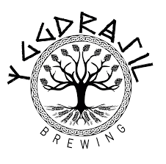
As always, please send me photos of your amazing work so I can upload
them to the website:
jfoster@stcatherinesbridport.dorset.sch.uk
Thank you! Enjoy your learning!
Mrs Foster x

