Aaaaaahhhhhh!
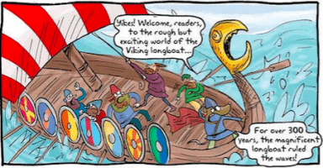
THE VIKINGS ARE COMING!!
Who is that approaching?
Are they friendly or do they just want a good fight?
Are you ready to find out?

Creative Topic Learning – Weeks 1-2
Week 1 – Who were the Vikings?

This week, aim to answer the following questions:

- Who were the Vikings?
- Where did they come from?
- How did they get here?
- Why did they come?

Choose from the options below:

- Who were the Vikings?
https://www.bbc.co.uk/bitesize/topics/ztyr9j6/articles/zjcxwty
- Where did the Vikings come from?
https://www.bbc.co.uk/bitesize/clips/zv2mhyc
- Read the information sheet on Vikings.
- Cut out and order the Viking timeline cards.
- Make your own Viking invasion map using the example.

Present your learning in your own way.

Week 2 - What were Viking Long ships like?

Choose from the options below:

- Viking Long ships
https://www.bbc.co.uk/bitesize/clips/zgmxpv4
- Read the information sheet and answer the questions about long ships.
- Use the template provided to create your own long ship.
- Carry out a DT investigation by designing and making your own mini long ship that can float in water and carry Vikings and their belongings (small objects!) across the water. Which shape and material works best?
- Extra idea: Print out a picture of yourself and add ‘Viking details’ like hair made of wool etc. then put yourself on your ship!

Present your learning in your own way.

Coming soon… Viking gods and sagas (myths)!

