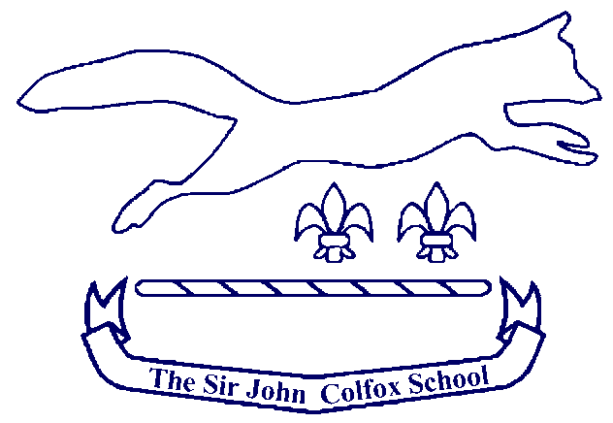

WEST DORSET PRIMARY SCHOOL
VIRTUAL CROSS COUNTRY TEAMS
January 2021

HANDBOOK
For
Parents

Please return your results to your school once you believe you have collected your child’s best time.

RESPONSIBILITIES OF PARENTS
- Ensure you provide your school with an accurate time.
- Have lots of fun.
Thank you for all your support with sport for your child during this difficult time. We hope you all stay safe during lockdown.
Yours in sport, Ryan Hobby & Andy David - Colfox Cross Country

Event Details

Distance
1000 metres
Recording Time(s)
If possible, please use a running app such a Strava or other equivalents as this will make it easier for you and provide accurate times.
Winners
Winners will receive a certificate.
Certificates will be awarded to teams entered in groups of 4:
Years 1 and 2 (2 boys and 2 girls make one team)
Years 3 and 4 (2 boys and 2 girls make one team)
Years 5 and 6 (2 boys and 2 girls make one team)

If schools have plenty of entries, we will create certificates for A, B and C races.

